OBSERVATION1:

When using forget password functionality, it is accepting password which is not as per requirement for password field.

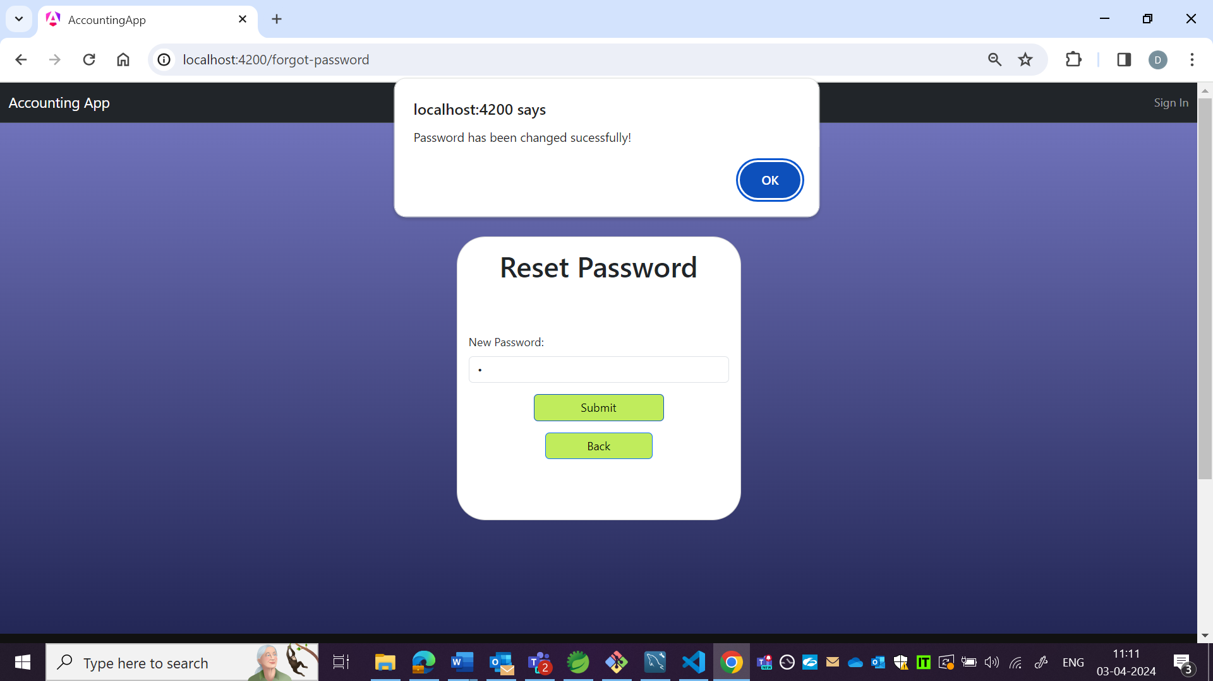



OBSERVATION2:

User is able to reset password without email verification.

